Unseen and Unheard

 | ‘Unseen and Unheard’ is a  report about research by the Disabled Children’s Partnership
 | The Disabled Children’s Partnership is a group of more than 110 organisations that campaign for disabled children and their families.
 | They did the research with families with disabled children from black and Asian minority ethnic groups. This included:  This included:
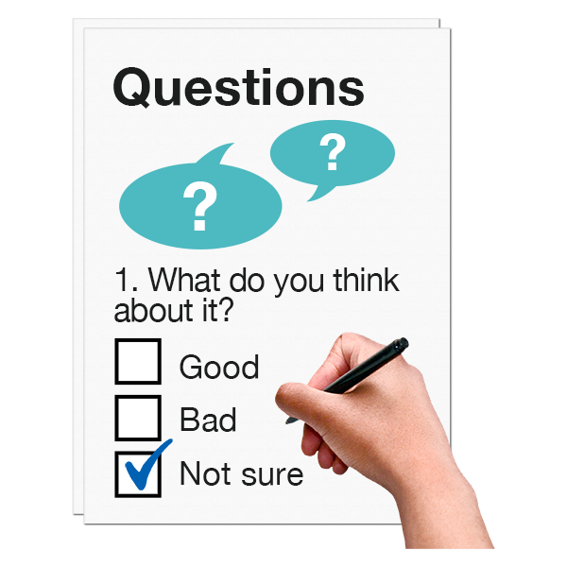   | - Online surveys with parents of disabled children during the pandemic.  - Review of other research that was published during the pandemic.
 | - Focus groups with parents of disabled black and Asian children and young people.
 | They wanted to know if the experiences were different for families with disabled children and young people who are white and those who are black or Asian.
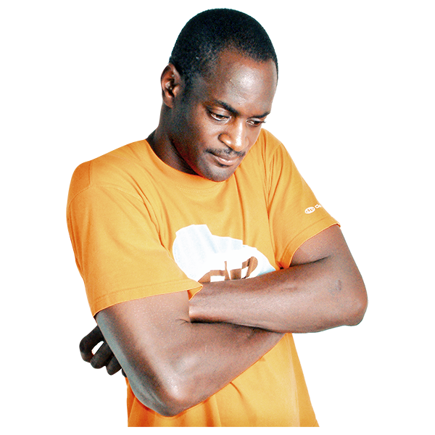 | The research found that parents of disabled children from black and Asian ethnic groups were more likely to have poor mental health, higher anxiety and be more isolated than white parents.
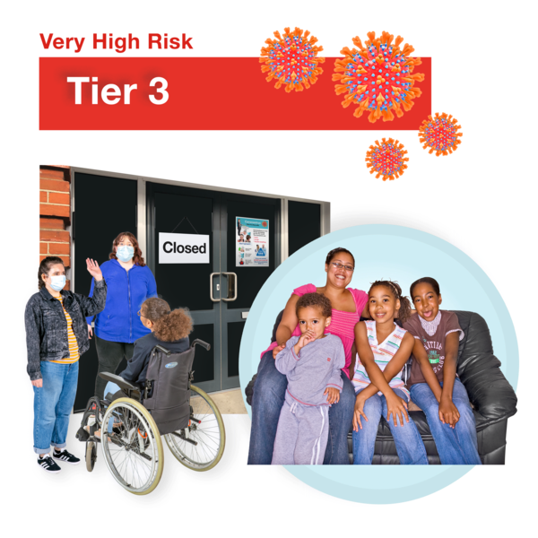 | Parents said that this was because reporting around COVID-19 talked about a higher risk for people from black and Asian ethnic groups.
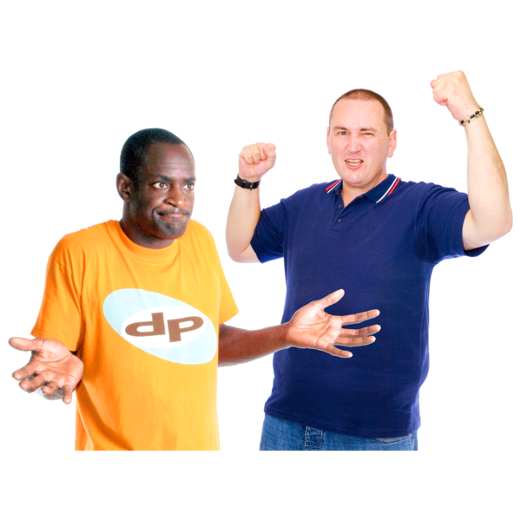 | Parents told us that they suffered more racial abuse because of this during the pandemic.
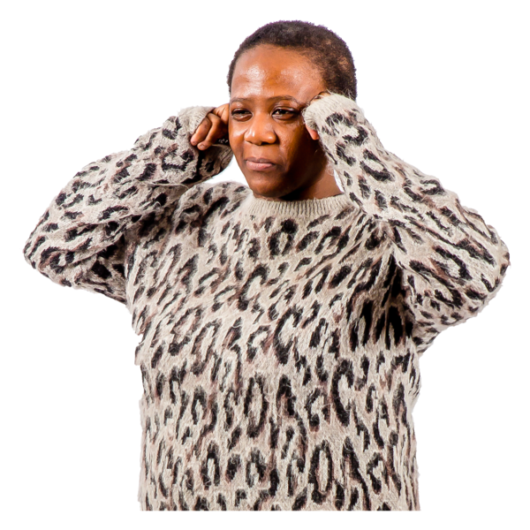 | Racism, racial abuse and reporting about COVID-19 made parents feel more isolated and had poorer mental health than white parents of disabled children.
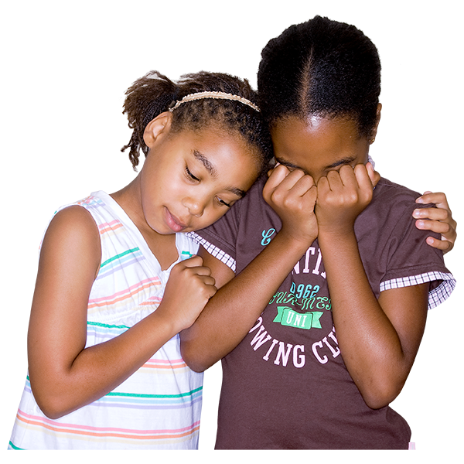 | Disabled children from black and Asian minority ethnic groups were more isolated than white disabled children.
 | The Disabled Children’s Partnership want to make sure disabled children and their families from black and Asian groups are supported better if there is another pandemic.
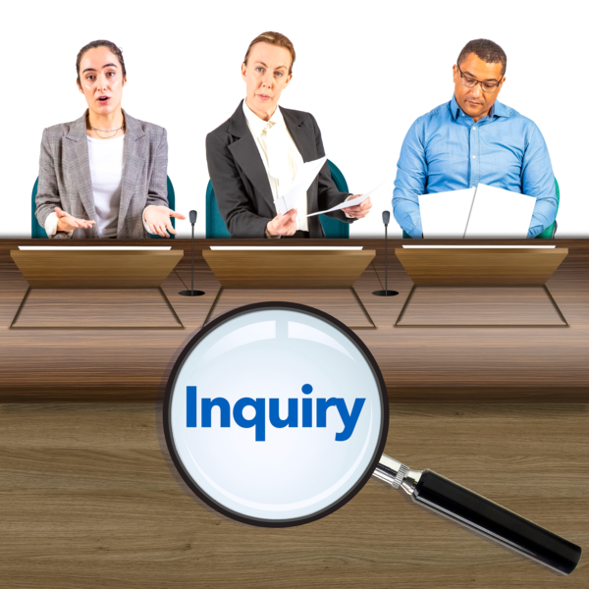 | The Covid-19 Inquiry must hear the experiences of families with disabled children from black and Asian communities.
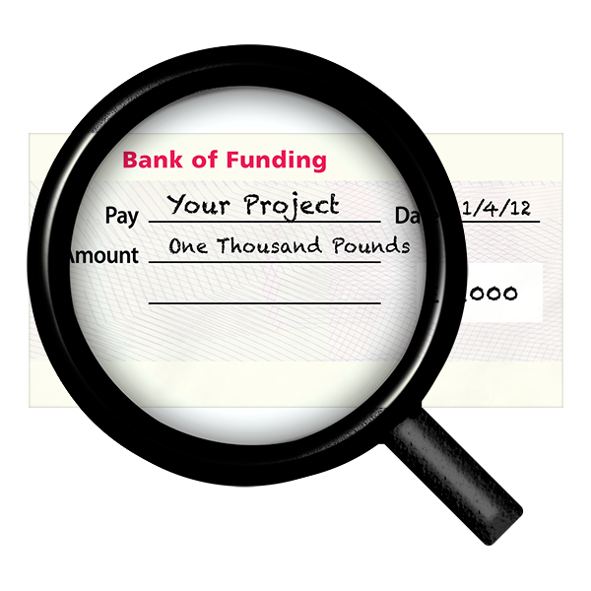 | Research should be funded to make sure the experiences of families with disabled children from black and Asian ethnic groups are looked at in more detail.
 | Government departments such as Health and Social Care and Education should look at how information about ethnicity can be collected better.

